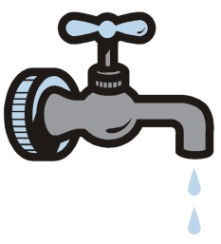
Tap or Bottled Water Poster
Choose a Side!
You will be creating a persuasive poster for either tap or bottled water. You must make a claim, illustrate that claim and write at least 4 supports for that claim on the poster.
PUT YOUR NAME, DATE AND PERIOD NUMBER ON THE PAPER
DO THESE STEPS IN ORDER!!!
- Choose either tap or bottled water
- Using your claims and supports AND the articles- choose a claim
- Find 4 or more supports that you will use
- Create a catchy heading that states your claim, write it on the poster (BIG)
- Write the supports on the poster (leave room for the illustrations)
- Illustrate your poster with one or more drawings or cartoons
- Color your poster Use your creativity and humor.
Poster Grading Rubric- 40 total points
Claim-10 | Supports-10 | Organization/ Neatness-10 | Creativity-10
10-9  -An important claim is made | 10-9  -Four or more strong supporting evidence | 10-9  -Thoughtfully organized, very neat and fully colored | 10-9  -A catchy, creative, funny or persuasive heading is present
8-7  A claim is made | 8-7  Three strong supporting evidence | 8-7  Organized, neat and colored | 8-7  A good heading is present
6-0  A poor claim is made | 6-0  Three or less supporting evidence | 6-0  Organized might not be colored | 6-0  A heading is present

